Enter the Title of your Abstract here

Enter the list of authors here, e.g., A. Savinkov¹, B.C. Korepanov². The presenting author should be underlined

Enter the list of affiliations here, e.g.,
¹Zavoisky Physical-Technical Institute, Kazan, Russian Federation
²Institute of Physics, Kazan Federal University, Kazan, Russian Federation

e-mail: enter the e-mail address of the presenting author here

Enter the main text here. Abstract should be written in English and should satisfy the following format requirements: Paper size - A4. Margins - 2.5 cm all sides (left, right, top, bottom). Font - Times New Roman, 12 pt for Title, Authors, Affiliations, e-mail of presenting author, Main text, References [1]; 10 pt - for Figure captions. Only the Title should be in Bold font. The Title and Authors should be centered. Please underline the presenting Author. Affiliations and e-mail address of presenting author should be left aligned. Insert one blank line after the Title, Authors, Affiliations and e-mail address of presenting author. The main text should be justified with a single spacing. The Figures (if any) should be embedded in the text. Formulas (if any) should be specified using MS Word Equation Editor. The abstract file should be saved in MS Word (*.doc, *.docx) or Rich Text Format. It is recommended to name the file with the name of the corresponding author, e.g. Petrov.rtf, Petrov.doc. It is recommended to compress the file using WinZip or compatible software (Petrov.zip). File size should be no more than 2 megabytes.
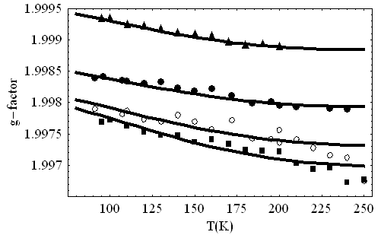
Fig.1. Font size of the figure caption – 10 pt. The Figure should be embedded in the text.
Please prepare one-page Abstarct using MS Word Editor. Abstract should be written in English and should satisfy the following format requirements: Paper size - A4. Margins - 2.5 cm all sides (left, right, top, bottom). Font - Times New Roman, 12 pt for Title, Authors, Affiliations, e-mail of presenting author, Main text, References [2]; 10 pt - for Figure captions. Only the Title should be in Bold font. The Title and Authors should be centered. Please underline the presenting Author. Affiliations and e-mail address of presenting author should be left aligned. Insert one blank line after the Title, Authors, Affiliations and e-mail address of presenting
(1)
author. The main text should be justified with a single spacing. The Figures (if any) should be embedded in the text. Formulas (if any) should be specified using MS Word Equation Editor. The abstract file should be saved in MS Word (*.doc, *.docx) or Rich Text Format. It is recommended to name the file with the name of the corresponding author, e.g. Petrov.rtf, Petrov.doc.

[1] M. Cardona, Phys. Stat. Sol. (a) 188, 1209 (2001).
[2] P.B. Allen, Phys. Rev. B 18, 5217 (1978).

